Shakti Website Change Suggestions
Get Involved
================My Work========================
New Section- CSR Partnership Section to be created- 1. Paragraph- 2. Image required
New Section-Donation in kind- 1. Fix Content, 2. Photograph & Paragraph & PDF provision required.
Slider section image caption remove and photo added from old site..
Our Reach counter section add in before Impact Of Our Works section..
Old Reach Us section remove from home page.
Project dropdown menu added 1- current project 2. Completed project and also table format view .
individual_supporters not fetching from admin panel..
In Contact Page add this section..

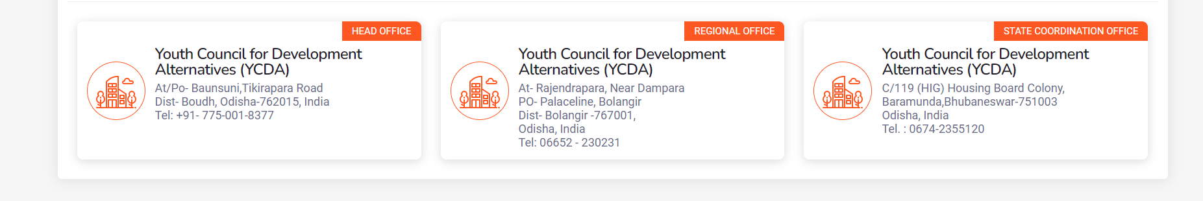
Donate-National & International Page with rozerpay to be added, and scanner to be added.

Contact Us: style https://ycdaindia.org/contact-us/

